**Table of Content:**

|  |  |  |
| --- | --- | --- |
| **Serial No** | **Topic** | **Page No** |
| **1** | Introduction | 3 |
| **2** | Classification | 3-4 |
| **3** | Assisted Dying | 5 |
| **4** | Principle of Medical Ethics | 5 |
| **5** | Ethical Dilemmas | 6 |
| **6** | Arguments for and against Euthanasia | 6 |
| **7** | Myths | 7-8 |
| **8** | Statistics | 8 |
| **9** | A story of a Dutch teenager Noa Pothoven | 9 |
| **10** | Religious and Sociological Perspective | 9 |
| **11** | World Record | 10-11 |
| **12** | Legislation | 11 |
| **13** | Conclusion | 12 |
| **14** | References | 13 |

***Mercy Killing***

**Introduction:**

An easy or painless death or the intentional ending of the life of a person suffering from an incurable or painful disease at his or her request is called Mercy Killing. It is also called

Euthanasia. One widely-accepted definition of euthanasia is “a deliberate intervention undertaken with the express intention of ending a life, to relieve intractable suffering.” It‟s also simply called “mercy killing. A person who undergoes euthanasia usually has an incurable condition. But there are other instances where some people want their life to be ended. In many cases, it is carried out at the person's request but there are times when they may be too ill and the decision is made by relatives, medics or, in some instances, the courts. The term–also called “right to die”–is most often used to describe voluntary euthanasia, though it is also used in reference to non-voluntary euthanasia and involuntary euthanasia.

**Classification of Euthanasia**:

Euthanasia may be classified into three types, according to whether a person gives informed consent→

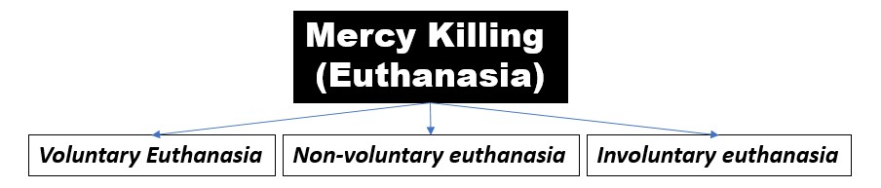

* ***Voluntary Euthanasia:*** Voluntary euthanasia is legal in a growing number of countries.

Euthanasia can be voluntary even if the person is no longer competent to assert her wish to die when her life is ended. You might wish to have your life ended should you ever find yourself in a situation where, whilst suffering from a distressing and incurable condition, illness or accident have robbed you of all your rational faculties, and you are no longer able to decide between life and death. If, whilst still competent, you expressed the considered wish to die when in a situation such as this, then the person who ends your life in the appropriate circumstances acts upon your request and performs an act of voluntary euthanasia. [3]

* ***Non-voluntary euthanasia:*** Non-voluntary euthanasia (patient's consent unavailable) is legal in some countries under certain limited conditions, in both active and passive forms. Euthanasia is non-voluntary when the person whose life is ended cannot choose between life and death for herself – for example, because she is a hopelessly ill or handicapped newborn infant, or because illness or accident have rendered a formerly competent person permanently incompetent, without that person having previously indicated whether she would or would not like euthanasia under certain circumstances. [3]
* ***Involuntary euthanasia:*** Involuntary euthanasia (without asking consent or against the patient's will) is illegal in all countries and is usually considered murder. Euthanasia is involuntary when It is performed on a person who would have been able to give or withhold consent to her own death, but has not given consent – either because she was not asked, or because she was asked but withheld consent, wanting to go on living. Whilst clear cases of involuntary euthanasia would be relatively rare (for example, where A shoots B without B‟s consent, to save her from falling into the hands of a sadistic torturer), it has been argued that some widely-accepted medical practices (such as the administration of increasingly large doses of pain killing drugs that will eventually cause the patient‟s death, or the unconsentedto withholding of life-sustaining treatment) amount to involuntary euthanasia. [3]

Voluntary, non-voluntary and involuntary types can be further divided into passive or active variants.

 Passive euthanasia entails the withholding treatment necessary for the continuance of life.

 Active euthanasia entails the use of lethal substances or forces (such as administering a lethal injection), and is more controversial.

While some authors consider these terms to be misleading and unhelpful, they are nonetheless commonly used. In cases, such as the administration of increasingly necessary, but toxic doses of painkillers, there is a debate whether or not to regard the practice as active or passive. [1]

**Assisted Dying:**

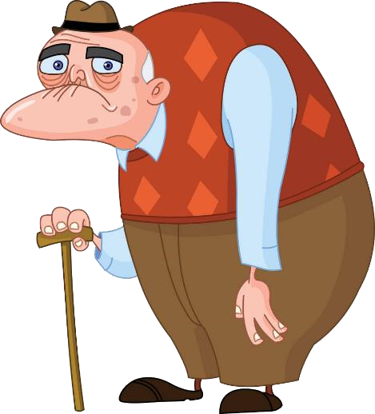Assisted suicide is about helping someone to take their own life at their request – in other words the final deed is undertaken by the person themselves. [Assisted dying](https://www.theguardian.com/society/assisted-suicide) can be used to mean both euthanasia, generally voluntary, and assisted suicide; however, some campaign groups use it to refer only to assisted suicide of terminally ill people. Euthanasia refers to active steps taken to end someone‟s life to stop their suffering and the “final deed” is undertaken by someone other than the individual, for example a doctor. If the person concerned has requested this, it falls under the term “voluntary euthanasia”. [7]

**Principle of Medical Ethics:**

Basically mercy killing is under medical term as the decision of death or the intentional ending of the life of a person suffering from an incurable or painful disease is handed over to doctor. But, doctor has to abide by the medical ethics for his profession.

In the first part, the oath consists of a declaration that the physicians will have respect for parents and teachers and will provide all help, even monetary assistance, to them when needed. The oath says that they will abide by the Physicians‟ laws and none other. The second part of the oath has five ethical principles:

**Five Ethical Principles**:

* The physicians will treat the sick according to their abilities and judgment and will not do any harm or wrong to the sick people.
* They will not administer poison to any one even if asked to do so.
* They will not cause abortion.
* They will keep themselves free from fornication with women or men, bond or free. ● They will maintain secrecy regarding their patients and their diseases.

**The Ethical Dilemmas of Euthanasia:**

Ethical Dilemmas, also known as moral dilemmas Euthanasia raises a number of agonizing moral dilemmas:

* + Is it ever right to end the life of a terminally ill patient who is undergoing severe pain and suffering?
  + Under what circumstances can euthanasia be justifiable, if at all?
  + Is there a moral difference between killing someone and letting them die? [2]

**Arguments for Euthanasia:**

There are many arguments that have been put forward for and against euthanasia. A few of the main arguments for and against euthanasia are outlined below. Advocates of euthanasia argue that a patient has the right to make the decision about when and how they should die, based on the principles of autonomy and self-determination. It is said that relieving a patient from their pain and suffering by performing euthanasia will do better than harm. Advocates of euthanasia express the view that the fundamental moral values of society, compassion and mercy, require that no patient be allowed to suffer unbearably, and mercy killing should be permissible. [4]

**Arguments against Euthanasia:**

It has also been argued that patients‟ requests for euthanasia are rarely autonomous, as most terminally ill patients may not be of a sound or rational mind. Active voluntary euthanasia and physician-assisted suicide undermine the doctor-patient relationship, destroying the trust and confidence built in such a relationship. A doctor‟s role is to help and save lives, not end them. Casting doctors in the role of administering euthanasia “would undermine and compromise the objectives of the medical profession. [4]

**Myths of Euthanasia or Assisted Suicide:**

The debate over euthanasia and assisted suicide has resurfaced in Canada. Bill C-384, a Private Member‟s Bill, is before the House of Commons for debate a second time next week. In order to know the foundational issues of this discussion and regarding this bill, here are the top five myths surrounding euthanasia and assisted suicide:

# Euthanasia and assisted suicide are all about choice

C-384 gives doctors permission to aid in suicide or kill without fear of prosecution if they and their patients meet certain criteria. The Bill actually protects doctors more than it gives choice to individuals. And doctors have no manner of ensuring that such a person is not under influence by another. To put it bluntly, if a relationship has soured between a caregiver and a vulnerable person, we have no way of assuring that the vulnerable are not strongly influenced to die early.

# Euthanasia and assisted suicide give people control over the time, place, and method of their death

C-384 requires that the individual sign an effective power of attorney to appoint someone to kill them if/when they no longer “appear lucid”. It requires the doctor to “(act) in the manner indicated by the person” when assisting in their suicide or killing them. But the reporting mechanism in the bill leaves no room for accountability. Once again, doctors, not patients are in control.

# It’s happening already. We should therefore legalize it

Apparently, bringing euthanasia and assisted suicide out of the shadows and into law will make it safer through regulation. Yet C-384 requires the doctor assisting in the suicide or killing the individual to forward only a copy of that person‟s diagnosis to the coroner. No record need be kept that the person actually died by assisted suicide; the coroner would have no trace of assisted suicide and therefore no way to test how accountable the doctor is to the law. Hardly safe, hardly out of the shadows.

# Without legalized euthanasia and/or assisted suicide, people suffer and die a lengthy, painful death

The suffering of those with painful terminal illnesses is emotional and very difficult both for the patient and family members. This cannot be romanticized and watching a loved one in pain is a terrible burden. However, good palliative care alleviates this pain and palliative care specialists do not wish to keep people alive simply for the sake of it. Palliative care teams seek to walk with the patient and their family on that road to natural death, treating and alleviating individual and family pains of all sorts.

# Euthanasia and assisted suicide are part of palliative care. Making them legal only offers more choice to patients

Currently, palliative care strives to help a patient and their family physically, emotionally, spiritually and mentally to die well, naturally. Euthanasia and assisted suicide interject human action or medical intervention to kill. The two are mutually exclusive. If this confusion is allowed to take root, then terminally ill patients seeking to die well naturally will not want to go to a palliative care ward for fear of being killed too soon. [5]

**Statistics of Euthanasia or Assisted Suicide:**

Total figures from around the world are hard to collate. [Figures from Switzerland](https://www.bfs.admin.ch/bfs/de/home/statistiken/gesundheit/gesundheitszustand/sterblichkeit-todesursachen/spezifische.assetdetail.7008105.html) show that the numbers of those living in the country who underwent assisted suicide rose from 187 in 2003 to 965 in 2015.According to the [2017 Regional Euthanasia Review Committees](https://derechoamorir.org/wp-content/uploads/2019/04/2018-Informe-anual-NL-2017-eng.pdf) (RTE), in the Netherlands there were 6,585 cases of voluntary euthanasia or assisted suicide – 4.4% of the total number of deaths. About 96% of cases involved euthanasia, with less than 4% assisted suicide, and the largest proportion of cases involved people with cancer. [7]

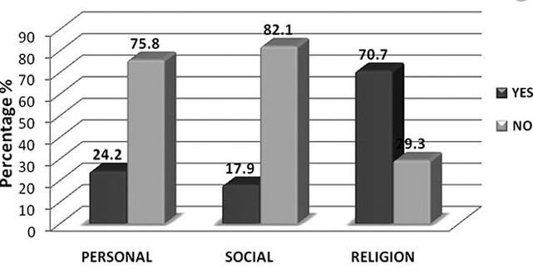

**A story of a Dutch teenager Noa Pothoven**

Noa Pothoven, who was 17, died last month – she had anorexia and severe depression. At first media reports suggested she had been “legally euthanized”, but later reports said it was unclear how she died, with her friends releasing a comment saying that she died after she stopped eating and drinking. Van der Heide said that while she could not comment on Poth oven‟s case, it is possible for minors over the age of 12 to seek euthanasia or assisted suicide in the Netherlands, under certain conditions. [7]

**Religious Perspective:**

Central to the argument against euthanasia is society‟s view of the sanctity of life, and this can have both a secular and a religious basis. The underlying ethos is that human life must be respected and preserved. The Christian view sees life as a gif offered God, who ought not to be off ended by the taking of that life. Similarly, the Islamic faith says that “it is the sole prerogative of God to bestow life and to cause death.” The withholding or withdrawal of treatment is permitted when it is futile, as this is seen as allowing the natural course of death. Official religious opposition (for example, from the Roman Catholic Church) does, however, remain unchanged, and active euthanasia remains a crime in every nation other than the Netherlands. [4]

**Sociological Perspective:**

# *“Euthanasia is a social issue, not just a medical debate”*

The potential of medicine to intervene to prolong or shorten the life of those considered to be dying or of those whose life is rated as of little or even negative value has only recently surfaced. It is an issue likely to affect society and the normative social relationships which that society believes it is its duty to promote. It is probable that, covertly members, of the medical profession have long played a role in speeding up the process of dying, with or without the consent of affected in individuals. Sociologists are beginning to study the circumstances surrounding the issues and the wider societal implications of possible changes in the law, professional practices and normative values. Their work may well begin to influence public policy as well as private practice. [6]

**World Record of Mercy killing:**

In many countries, voluntary euthanasia is legal such as in the Netherlands, Switzerland, Belgium, and Luxembourg and in the US states of Oregon and Washington. The first countries to legalize euthanasia were [**the Netherlands**](https://www.britannica.com/place/Netherlands) in 2001 and [**Belgium**](https://www.britannica.com/place/Belgium) in 2002. Most people think unbearable pain is the main reason people seek euthanasia, but some surveys in the USA and the Netherlands showed that less than a third of requests for euthanasia were because of severe pain. Belgium would become the next country to change its laws on mercy killing, as a bill to partially decriminalize euthanasia is currently before parliament.

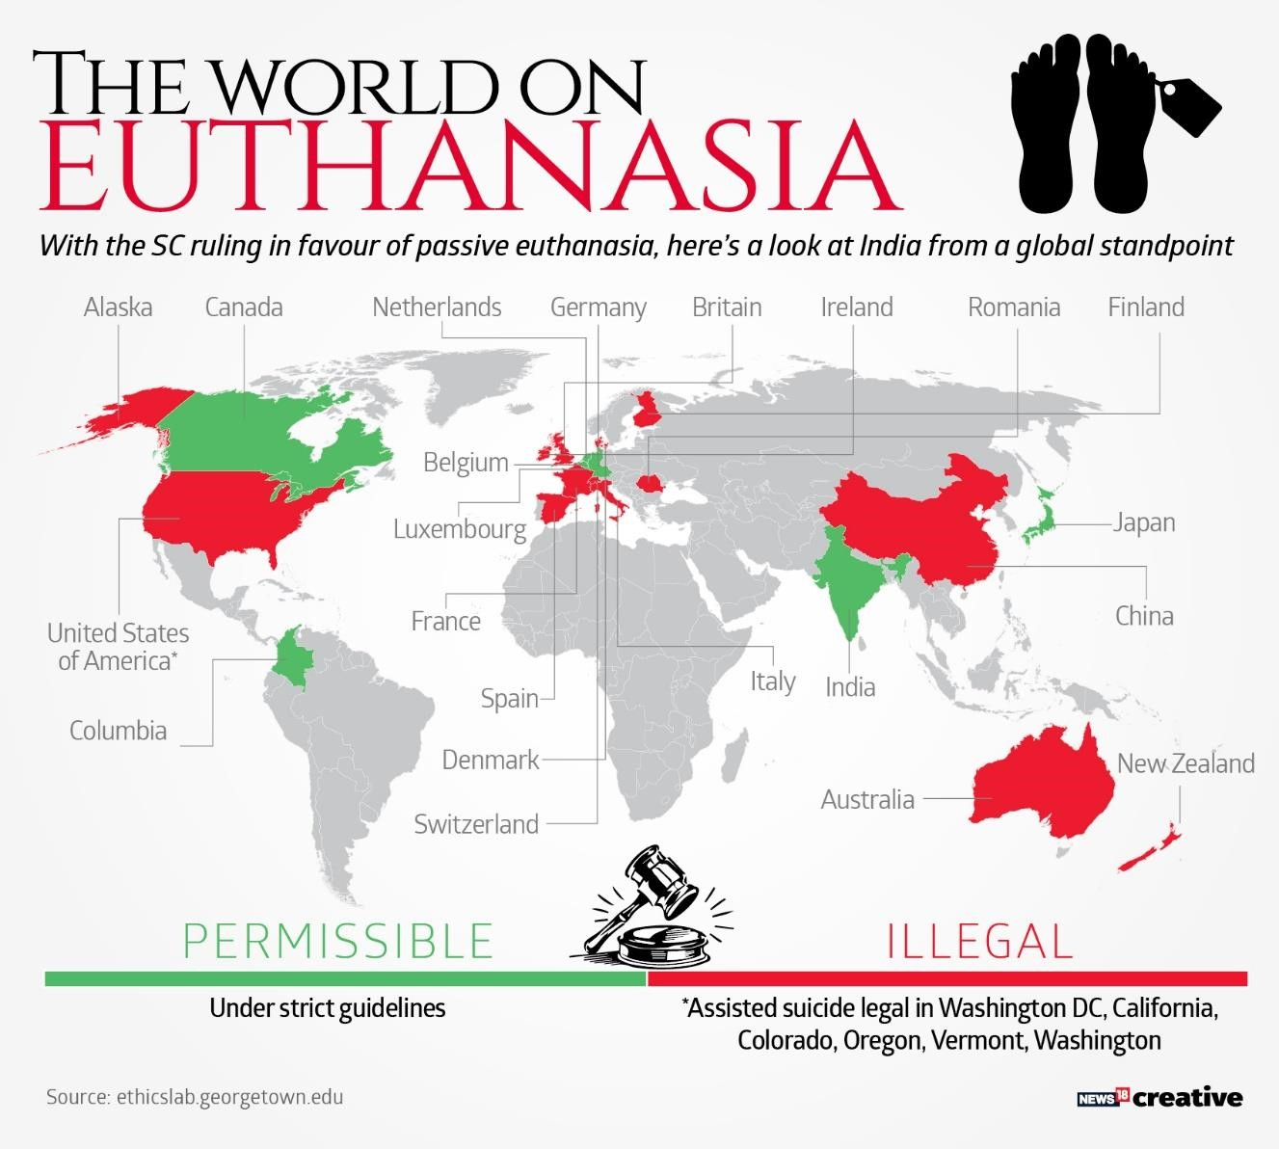

In Belgium, 72% of the population is believed to support some sort of death on demand. There, a series of court cases, beginning in 1973, have established the conditions under which doctors, and only doctors, may practice euthanasia: the decision to die must be the voluntary and considered decision of an informed patient; there must be physical or mental suffering which the sufferer finds unbearable; there is no other reasonable (i.e. acceptable to the patient) solution to improve the situation; the doctor must consult another senior professional. [9]

**Legislation:**

Under new legislation a doctor will not be prosecuted for terminating a person‟s life providing he or she is convinced that the patient‟s request is voluntary and well-considered and that the patient is facing „„unremitting and unbearable‟‟ suffering. The doctor must have advised the patient of his or her clinical condition and have reached a firm conclusion with the patient that there is „„no reasonable alternative‟‟. The new legislation will be written with all the checks and balances required to ensure that euthanasia is strictly limited to those who request it. Many doctors are doing it now, so it‟s sensible to make it legal so that they don‟t risk prosecution for murder.



The authorities will be able to keep track of its use because doctors who administer it will be required to complete appropriate reports when they do it. The legislation assumes that doctors can accurately predict how long it will take for a sick person to succumb to their illness. (Only people with terminal illness i.e. expected to die in 12 months or less or who have a prolonged debilitating illness will be eligible for euthanasia in the proposed bill). People are fully capable of exercising choice in matters of life and death. Euthanasia guarantees “death with dignity “The majority of those requesting euthanasia are in severe physical distress. [8]

**Conclusion:**

It can be seen that euthanasia is indeed a contentious issue, with the heart of the debate lying at active voluntary euthanasia and physician assisted suicide. It‟s legal status in Australia is that of a criminal offence, conferring murder or manslaughter charges according to the criminal legislation and/or common law across Australian states. Australia‟s prohibition and criminalization of the practice of euthanasia and assisted suicide reflects the legal status quo that is present in most other countries around the world. In contrast, there are only a few countries and states that have legalized acts of euthanasia and/or assisted suicide. The many arguments that have been put forward for and against euthanasia, and the handful that have been outlined provide only a glimpse into the ethical debate and controversy surrounding the topic of euthanasia. [4]

**References:**

1. <https://en.wikipedia.org/wiki/Euthanasia#Definition>
2. <http://www.bbc.co.uk/ethics/euthanasia/overview/introduction.shtml>
3. <https://www.worldrtd.net/euthanasia-fact-sheet/>
4. <https://www.amsj.org/archives/2066>
5. [https://www.imfcanada.org/archive/284/top-five-myths-about-euthanasia-and-assistedsuicide](https://www.imfcanada.org/archive/284/top-five-myths-about-euthanasia-and-assisted-suicide)
6. <https://pubmed.ncbi.nlm.nih.gov/8759236/>
7. [https://www.theguardian.com/news/2019/jul/15/euthanasia-and-assisted-dying-rates-aresoaring-but-where-are-they-legal](https://www.theguardian.com/news/2019/jul/15/euthanasia-and-assisted-dying-rates-are-soaring-but-where-are-they-legal)
8. <https://www.who.int/bulletin/archives/79%286%29580.pdf>
9. https://www.britannica.com/topic/euthanasia